BRICK

CATALOGUE

**AnunparalleledselectionCONTACTINFOBRICKS ofexclusivenatural**

**stonesthat**

**metamorphoseyour**

**homeintoluxuryliving.08049597764**

**Sales@flintstones.in**

**1074/E,11thMain,**

**HAL2ndStage,Indiranagar**

**Bengaluru,Karnataka560038**

**India**



**STORY** 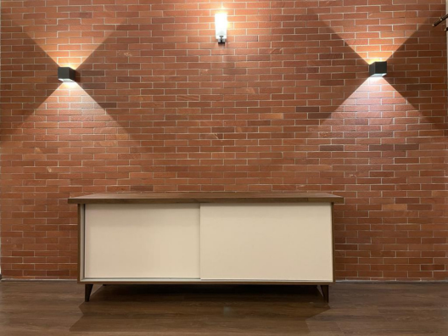

Extensively used in numerous application areas and its presence in almost every construction project has resulted in the diversification on it's build. Flintstones exhibits a comprehensive collection of bricks in it's various forms and patterns. Alterations can now be made on it's material content, shape, size and even among the shades of colors available. Flintstones holds a limitless collection of bricks and is furthermore looking to expand it's horizons.

**We're here to custom build all your desired spaces.**

**FEATURES**

Natural bricks can be customised to a great extent, including its colour, size

Alterations can also be made in the sizes offered.

Sustainabe & enduring

Visually stimulating

Various grouting options available A wide variety of options offered We offer a mix-match of different concepts, unique to each project. The finishes can be experimented with

To maintain consistent thickness on all bricks we calibrate the back of each brick

FACTORYMADE

F

MC0

1

F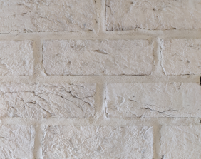

MC0

2

Size: 50x175mm Thickness: 10-13mm Tolerance: +/-5mm Grooves: 8mmwhite grout

Size: 65x205mm Thickness: 15-18mm Tolerance: +/-5mm Grooves: 12mmwhite grout

FACTORY

F

MC0

3

Size: 50x175mm Thickness: 13-15mm Tolerance: +/-5mm Grooves: 8mmwhite grout

MADESize: 50x175mm F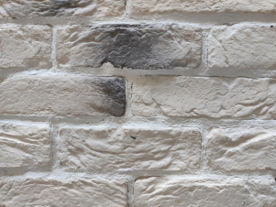

MC0

4

Thickness:13-15mm Tolerance: +/-5mm Grooves: 8mmwhite grout

FACTORY

F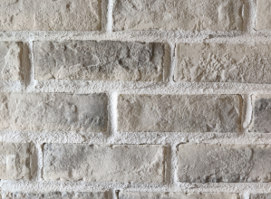

MC0

5

Size: 50x175mm Thickness:13-15mm Tolerance: +/-5mm Grooves: 8mm

Whitegrout

MADESize: 50x175mm F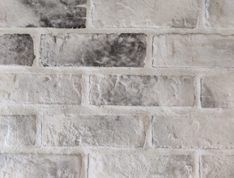

MC0

6

Thickness:13-15mm Tolerance: +/-5mm Grooves: 8mm

Whitegrout

FACTORY

F

MC0

7

Size: 50x175mm Thickness:13-15mm Tolerance: +/-5mm Grooves: 8mm

Whitegrout

MADESize: 50x175mm

F

MC0

8

Thickness:13-15mm Tolerance: +/-5mm Grooves: 8mm

Whitegrout

FACTORYMADE

F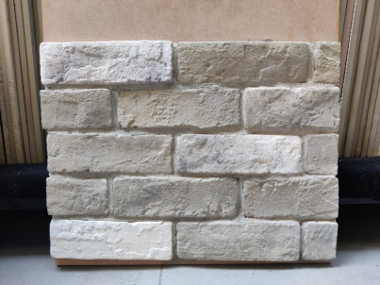

MC0

9

F

MC1

0

Size: 50x175mm Thickness:13-15mm Tolerance: +/-5mm Grooves: 5mm

Whitegrout

Size: 65x195mm Thickness: 17mm Tolerance: +/-5mm Grooves: PaperJoint

FACTORYMADE

F

MC1

1

F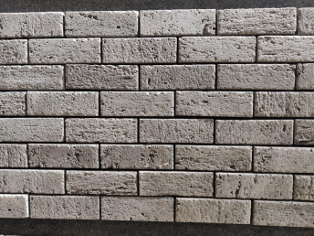

MC1

2

Size: 65x195mm Thickness: 17mm Tolerance: +/-5mm Grooves: PaperJoint 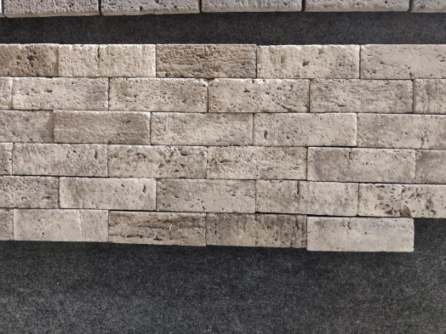

Size: 65x195mm Thickness:17mm Tolerance: +/-5mm Grooves: 3MM

FACTORYMADE

F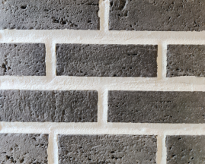

MC1

3

F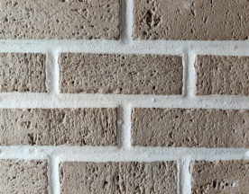

MC1

4

Size: 65x195mm Thickness: 17mm Tolerance: +/-5mm Grooves: 25MM WhiteGrout

Size: 65x195mm Thickness: 17mm Tolerance: +/-5mm Grooves: 25MM WhiteGrout

FACTORYMADE 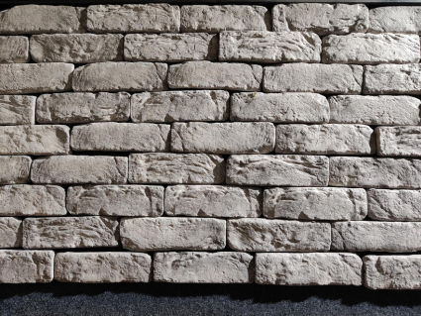

F

MC1

5

F

MC1

6

Size: 50x170mm Thickness:13-15mm Tolerance: +/-5mm Grooves: PaperJoint

Size: 50x170mm Thickness:13-15mm Tolerance: +/-5mm Grooves: PaperJoint

FACTORYMADE

F

MC1

7

F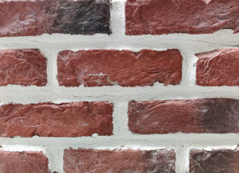

MC1

8

Size: 50x170mm Thickness:13-15mm Tolerance: +/-5mm Grooves: PaperJoint

Size: 50x170mm Thickness:13-15mm Tolerance: +/-5mm Grooves: 25MM WhiteGrout

FACTORYMADE

F

MC1

9

F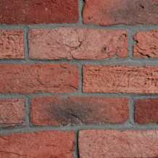

MC2

0

Size: 65x205mm Thickness:18-20mm Tolerance: +/-5mm Grooves: 20mm GreyGrout

Size: 65x205mm Thickness:18-20mm Tolerance: +/-5mm Grooves: 8mm

GreyGrout

FACTORY

F

MC2

1

Size: 50x175mm Thickness:13-15mm Tolerance: +/-5mm Grooves: 5MM

GreyGrout

MADESize: 50x170mm F

MC2

2

Thickness:13-15mm Tolerance: +/-5mm Grooves: 12MM GreyGrout

FACTORYMADE

F

MC2

3

F

MC2

4

Size: 65x205mm Thickness:18-20mm Tolerance: +/-5mm Grooves: 12mm GreyGrout

Size: 65x205mm Thickness:18-20mm Tolerance: +/-5mm Grooves: 12mm WhiteGrout

FACTORY

F

MC2

5

Size: 65x195mm Thickness: 17mm Tolerance: +/-5mm Grooves: 25MM WhiteGrout

MADESize: 65x205mm F

MC2

6

Thickness:18-20mm Tolerance: +/-5mm Grooves: 5mm

GreyGrout

NATURALSize: 50x200MM N

Thickness:10-12mm

B

Finish: SF/T

C

0

Grooves: 5mm

1

WhiteGrout

Size: 50x200MM 

N

Thickness:10-12mm

B

Finish: SF/T

C

0

Grooves: 5mm

2

BlackGrout

N

NATURALSize: 50x200MM

BC03

NBC04

Thickness:10-12mm Finish: SB

Grooves: 5mm

Size: 50x200MM Thickness:10-12mm Finish: SB/Cal 

Grooves: 5mm

White Grout

NATURALSize: 50x200MM N

B

Thickness:10-12mm

C

Finish: SB/T

0

Grooves: 5mm

5

WhiteGrout

N

Size: 75x225mm

B

Thickness:18-20mm

C

Finish: N/T

0

Grooves: 5mm

6

N

NATURALSize: 65x200mm

B

Thickness: 13-15mm

C

Finish: SB/CNC

0

Grooves: 3mm

7

N

Size: 65x200mm

B

Thickness: 13-15mm

C

Finish: SB/CNC

0

Grooves: 3mm

8

N

NATURALSize: 75X225MM

B

Thickness:13-15mm

C

Finish: SB-T/CNC

0

Grooves: PaperJoint

9

N

Size: 65x200mm

B

Thickness:13-15mm

C

Finish: SB/CNC

1

Grooves: 3mm

0

NATURALSize: 50x200mm

N

Thickness:10-12mm

B

Finish: Honed

C

Grooves: 3mm

1

GreyGrout

1

Size: 50x200mm

N

Thickness:10-12mm

B

Finish: SB/T

C

Grooves: 12mm

1

2

WhiteGrout

N

Size: 50x200mm

NATURALSize: 50x200mm

BC1

3

NBC1

4

Thickness:10-12mm Finish: SB/T

Grooves: 5mm

BlackGrout

Thickness:10-12mm Finish: Cal

Grooves: 5mm

GreyGrout

N

Size: 50x200mm

NATURALSize: 50x200mm

Thickness:10-12mm

B

Finish: Honed/Cal

C

1

Grooves: 5mm

5

White Grout

N

Thickness:10-12mm

B

Finish: Honed

C

1

Grooves: 5mm

6

GreyGrout

N

NATURALSize: 50x200mm

B

Thickness:10-12mm

C

Finish: SB

1

Grooves: 8mm

7

WhiteGrout

N

Size: 50x200mm

B

Thickness:10-12mm

C

Finish: SB-T/Cal

1

Grooves: 5mm

8

Grey Grout

NATURALSize: 75x225mm N

Thickness:12-15mm

B

Finish: SF/Hacked

C

1

Grooves: 8mm

9

WhiteGrout

Size: 50x200mm

N

Thickness:12-15mm

B

Finish: SF

C

2

Grooves: 12mm

0

WhiteGrout

**OUR**

P R O J E C T S

**Google, Bangalore**

**CRED, Bangalore**

**Google, Bangalore**

**Google, Bangalore**

**IBM, Hyderabad**

**Elli Lilly, Bangalore**

**Residential project**

**Residential project**



**Wiprogate,Sarjapurroad**



**WellsFargo,Bangalore**

**Residential project**

**Residential project**

**Google, Bangalore**



**Google, Bangalore Xiaomi, Bangalore**

**Residential project**

**Residential project**

**Xiaomi, Bangalore**